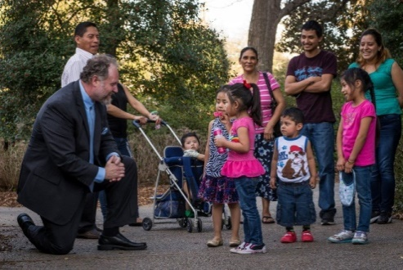 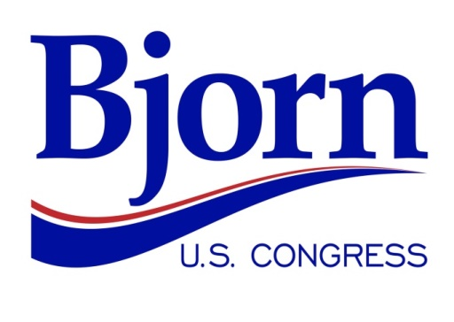 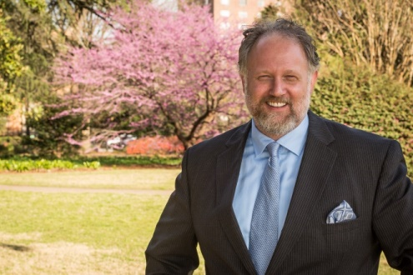

***There’s a Better Way!***

Bjorn for Congress Volunteer Form

Thank you for your interest in volunteering for my campaign to represent South Carolina’s 2nd Congressional District. Please take a few minutes to provide the following information, then return this form to [michelle@bjorn2run.com](mailto:michelle@bjorn2run.com) .

|  |  |  |  |  |  |  |  |
| --- | --- | --- | --- | --- | --- | --- | --- |
| Name (Last, First) | First Name Preferred | Street Address | City | State | Zip Code | Phone | Email |
|  |  |  |  |  |  |  |  |

**1. What campaigns have you work on previously?**

**2. Please provide a brief statement about your time availability between July 2016 and November 2016.**

**3. Please provide a brief statement about your Volunteer Skillset and Interests *(phone banking, event coordination, canvassing, fundraising, etc.)*. Please also indicate any unique talent *(e.g., music, stagehand, etc.)* that you are willing to contribute.**

You can already help the campaign now! Please follow our Facebook campaign page at [www.facebook.com/Bjorn2Run/](http://www.facebook.com/Bjorn2Run/) . Please use **the INVITE FRIENDS function** (see image below) and invite your Facebook friends. Inviting and sharing our posts—but especially INVITING—will help our ability to reach our neighbors through social media.

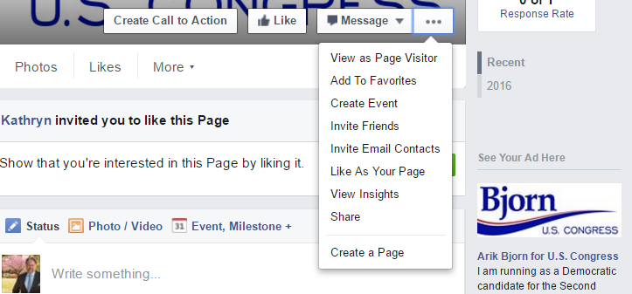

□ If you are interested in an academic internship, please indicate my checking this box.

*Please return this form to* [*michelle@bjorn2run.com*](mailto:michelle@bjorn2run.com) *. Use the subject line: “VOLUNTEER FORM.” We will be in touch as soon as possible. Thank you for your patience.*